HEALTH AND SAFETY STATEMENT

DE LA SALLE COLLEGE MACROOM

2023/ 2024

1. SCHOOL PROFILE

The school caters for approximately 440 students, mostly boys although there may occasionally be a number of girls in the ASD units. There is a teaching staff of 41, alongside 8 SNA’s and 10 ancillary staff including secretary, caretaker, cleaners and escorts.
- The large part of the school is confined to one, single-storey building
  - There is an individual classroom separate from the main building
  - There is also a storage “garage” adjoining this classroom
  - A prefabricated unit is located to the left of the main entrance gates; this serves as an ASD unit
  - Behind the main school is a large green area; this has goalposts and is used for sport and recreation. This field is owned by the diocese of Cloyne.
  - In September 2020, temporary accommodation in the form of a prefabricated building was opened to the Southern side of this field; this consists of nine rooms – four of which are dedicated to an ASD unit – four classrooms, a science laboratory with prep room and chemicals storage room, two resource rooms, storage rooms and toilet facilities, one for staff, one for disabled use and one for students.
  - In January 2022, a second temporary unit was opened alongside the first temporary unit. This is a two–storey unit, with 2 classrooms on the lower level and a concrete stairs leading to two more classrooms upstairs. There is a staff and disabled toilet on the ground floor and a student toilet on the first floor, together with a resource room.
  - Car parking facilities are on a tarmac surface at the front of the main building and to one side of the main building, with more parking available near the temporary accommodation units
  - A play area with basketball posts is on the Northern side of the main building
  - There is a dressing room with showers and toilets alongside the play area
  - Three large containers, positioned at one end of the basketball court, are used as storage facilities.

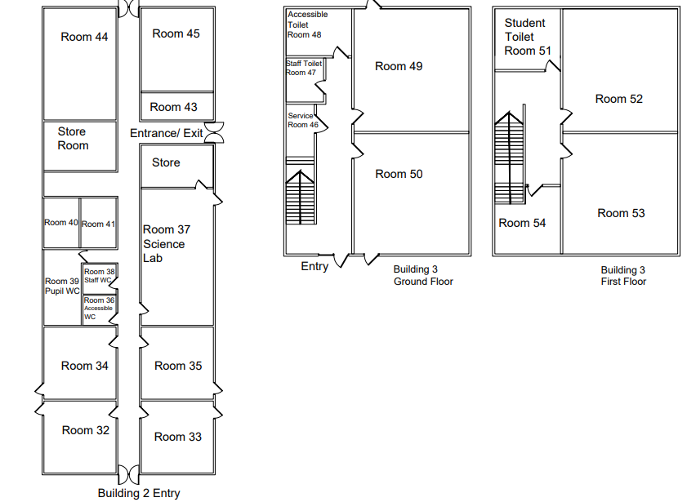

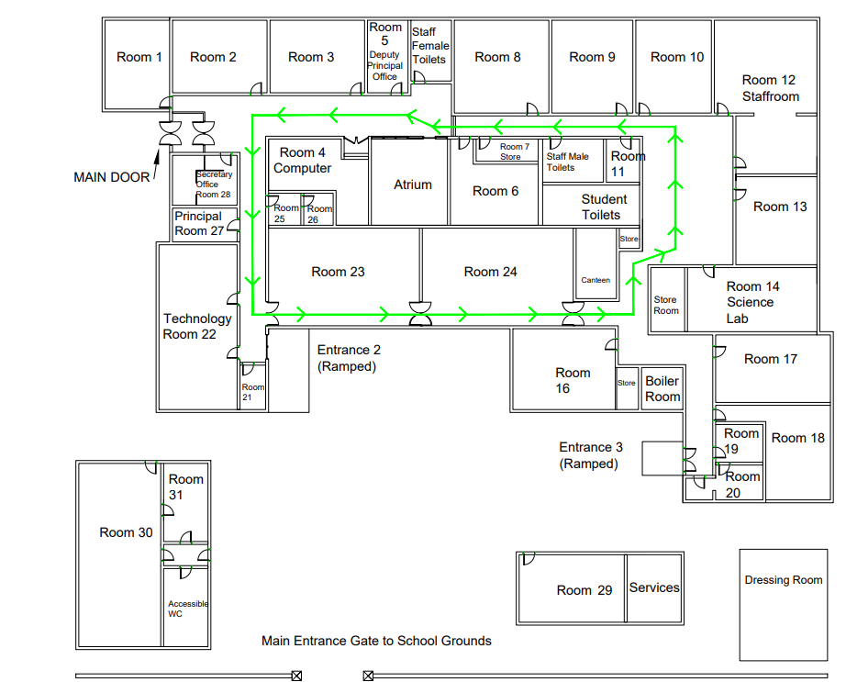
FIELD
BASKETBALL COURT

2. RESOURCES
- Location of First Aid kits:
  - Staffroom
  - Science laboratories
  - Technology Room
  - PE Room
  - 2 available to take to matches etc.

- Automated External Defibrillator, on the wall outside the office door

- Fire-fighting:
  - Fire alarm system
  - Science laboratories (powder extinguisher × 2) + fire blanket
  - Technology Room (water extinguisher)
  - Staff Room (CO₂ extinguisher)
  - Computer Room (CO₂ extinguisher)
  - Eating area in hall (powder extinguisher + fire blanket)
  - Fire hose (water) – corridor next to main office and opposite northern entrance to main hall

- Emergency lighting

- Intruder alarm and external lights

- Internal and external CCTV

- Also in Science Laboratories:
  - Chemical spill kit
  - Safety goggles
  - Eye wash station
  - Gloves
  - Gas proving systems
  - Gas and mains electricity cut-off switches
  - Fume extraction cupboards
  - Fume extraction system in chemicals stores

- Also in Technology Room:
  - Safety goggles
  - Electricity cut off switch
  - Dust masks
  - Safety posters and warning signs

3. HEALTH AND SAFETY MANAGEMENT STRUCTURE

ROLES AND RESPONSIBILITIES

- BOARD OF MANAGEMENT:

  - Has overall responsibility for Health and Safety matters in the school and shall comply with its legal obligations as employer under the 2005 Act
  - Shall receive the Health and Safety report from the safety committee, should one be in place
  - Shall review all risk assessments made
  - Shall review / update the safety statement at least annually, and when changes that might affect workers’ safety and health occur, in light of the Safety Committee’s (should one be in place) report and recommendations
  - Shall agree actions required and allocate resources where necessary
  - Shall identify short-, medium- and long-term priorities
  - Shall ratify safety and health decisions
  - Shall sign off on the safety and health policy and safety and health statement.

- PRINCIPAL:

- Shall convene meetings of the safety committee (should one be in place), a minimum of one per school term
- Shall take necessary actions on foot of agreed safety committee (should one be in place) decisions
- Shall ensure that required protocols for fire drills, accident reporting etc. are fulfilled
- Shall respond to safety and health reports, events and issues
- Shall brief staff on safety and health and report on issues as required
- Shall conduct a comprehensive walk-through inspection of the school – to include all equipment and furniture – along with the safety representative as per agreed schedule
- Shall keep a record of all issues pertaining to health and safety, including the nature of the issue and any preventative / corrective actions taken
- Shall report to the Board of Management on Safety and Health issues.

- SAFETY REPRESENTATIVE:

(Ms. Eva Dunne appointed as part of Assistant Principal duties as of September 2023)

  - Shall represent the employees in consultations with Management on matters of safety, health and welfare at the place of work
  - Shall conduct safety and health inspections alongside Principal as per agreed timetable
  - Shall make verbal or written representations on the employees’ behalf
  - Shall participate in investigations of accidents or dangerous occurrences
  - Shall liaise with Health and Safety Authority when required.

- SAFETY COMMITTEE (should one be in place):

  - To include the Principal, Safety Representative and a number of other individuals as selected from amongst the employees
  - Shall assist in the drafting and reviewing of the Health and Safety statement, risk assessments, policies and procedures
  - Shall establish a program for the year, e.g. risk assessments, walk-through inspections, fire drills etc.
  - Shall assess training needs, for both established requirements (First Aid – in conjunction with the staff member with particular responsibility for First Aid, Mr. Fergus Ryan at present) fire safety etc. and new or special requirements, e.g. new equipment
  - Shall agree necessary corrective actions in response to risk assessments.

- STAFF:
  - Shall comply with all statutory obligations on employees as designated under the 2005 Act
  - Shall monitor their classroom / immediate work area and ensure that it is safe and free from fault or defect and that equipment is safe before use; in the case of specialist rooms, such as the science and technology rooms, relevant teachers shall conduct regular inspections of their working area
  - Shall note and report (to the Principal or Safety Representative) any matter they regard to be a safety issue (e.g. slippery surfaces, damaged electrical appliances, worn electrical cables, sharp or protruding objects that may lead to injury etc.)
  - Shall complete risk assessments as appropriate to them as requested by the Board of Management and cooperate with school management and the Safety Committee (should one be in place) in the implementation of the safety statement
  - Shall ensure that risk assessments are carried out for new hazards, e.g. new machines, new chemical products etc.
  - Shall inform pupils of the safety procedures associated with individual subjects, e.g. science, technology, physical education etc.
  - Shall follow incident reporting procedure as required, i.e. reporting of accidents, “near misses” and dangerous occurrences

- OTHER SCHOOL USERS
- Other school users, e.g. pupils and other visitors, shall comply with school regulations and instructions relating to health and safety.

- CONTRACTORS
Where the school calls on the services of a smaller contracting company or a single contractor, with the work not exceeding 30 days or 500 person-days:

- Contractors must comply with statutory obligations as designated under the Safety, Health and Welfare at Work Act 2005, the Safety, Health and Welfare at Work (General Application) Regulations 2007 and any other relevant legislation such as the Safety, Health and Welfare at Work (Construction) Regulations 2006
- The school shall make available the relevant parts of the safety statement to any contractors working in the school on behalf of the school
- The school shall provide the contractors with school regulations and instructions relating to safety and health
- Contractors must make available relevant parts of both their safety statement and risk assessments in relation to work being carried out
- The school and contractors shall cooperate with each other and coordinate their activities in order to prevent risks to safety and health at work
- It shall be the responsibility of the Board of Management to ensure that any contractor appointed is competent and suitably qualified
- The Principal and the contractor shall meet before any project commences to ensure that communication links are established and maintained throughout the duration of the contract
- The contractor should advise the Principal of the likely duration of the work and any possible hazards, and how these will be addressed; the contractor shall provide the Principal in advance of commencement of the work with a copy of their safety statement to include any relevant risk assessments for the project
- The Principal shall advise the contractor about necessary precautions that need to be considered, in particular if the work is being carried out during school time
- School employees shall be informed of the work being carried out and of the impact it will have on school activities, including any necessary changes that may be made.

Where substantial building work is to be done, lasting more than 30 days or 500 person-days:

- The Board of Management shall take on the responsibility of “the client”
- The client shall:
  - Appoint, in writing and before design work starts, a Project Supervisor for the Design Process (PSDP)
  - Appoint in writing, and before construction begins, a Project Supervisor for the Construction Stage (PSCS) who has adequate training, knowledge, experience and resources
  - Cooperate with the project supervisors and supply any necessary information
  - Notify the HSA of the appointment of the PSDP on approved form AF1 “Particulars to be notified by the Client to the Health and Safety Authority before the design process begins”
  - Retain and make available the safety file for the completed structure – the safety file contains information on the completed structure that will be required for future maintenance or renovation.
- The PSCS further develops the safety and health plan for the construction stage of the project. This includes coordinating appropriate health and safety arrangements on site to prevent accidents occurring, e.g. keeping vehicles and people apart
- Prior to carrying out any construction work the Board of Management shall familiarise themselves with their legal health and safety responsibilities as clients as detailed in the Safety, Health and Welfare at Work (Construction) Regulations 2006.

4. RISK ASSESSMENTS

- A formal risk assessment shall consist of the following steps:
  - Hazards shall be identified
  - The potential for harm of the risk shall be evaluated
  - Control measures shall be put in place
- Formal risk assessments shall be carried out, in the main, by the Principal in conjunction with the Safety Representative
- A record, either written or electronic, shall be kept of the results of these assessments
- In specialist situations, for example the science or technology rooms, formal risk assessments shall be carried out by a competent teacher
- Control measures shall be put in place to ensure that the risk of an incident or accident from an identified hazard is reduced or eliminated; matters requiring urgent attention shall be addressed with due haste
- Where appropriate, employees shall be consulted on these control measures and how they may be affected by them
- If new equipment etc. presents a new hazard to the work environment or notably alters the current system of work, a revised risk assessment shall be carried out
- Risk assessments shall be reviewed by the Principal and Safety Representative or Safety Committee (should one be in place) periodically to monitor progress on any issues that have been identified.

5. FIRE SAFETY

- An emergency evacuation plan shall be in place
- The details of the plan shall be communicated to all parties and shall be on display
- The plan shall account for persons with disabilities and special needs
- Fire assembly points shall be identified and marked
- Directional signals shall be displayed throughout the school to guide people out of the building in the most efficient way
- Should a fire break out downstairs in the two-storey temporary accommodation, a 30 minute rating applies allowing people upstairs to escape before the fire can spread; in addition, the skylight in the upstairs ceiling will open automatically to clear away any smoke
- All fire exits shall be kept clear
- A minimum of two fire drills shall be held per year
  - These drills will be monitored for efficiency and timing
  - The success of the evacuation plan will be reviewed after each drill
- Fire-fighting equipment shall be available
- All fire-fighting installations and equipment shall be inspected as per legal requirements.

6. FIRST AID

- The school shall have an appropriate number of occupational First-Aiders on the premises
- Employees shall be made aware of the identities of the First-Aiders and the location of First Aid kits
- All appropriate equipment etc. shall be made available to the First-Aiders
- All First Aid kits shall be fully compliant with legislation and guidance
- As part of his Post of Responsibility, Mr. Fergus Ryan has been appointed to oversee proper maintenance of the First Aid kits.
- Particular health concerns of students and or / staff, including in relation to allergic responses, shall be communicated in a sensitive manner (taking GDPR into account) to all staff who may be involved in dealing with any implications of these concerns.

7. ACCIDENTS AND DANGEROUS OCCURRENCES

- All accidents and near misses / dangerous occurrences shall be recorded
- The Board of Management shall report specific incidents as required to the Health and Safety Authority
- A log shall be made available in the staff room (next to the First Aid kit) where employees shall record the details of any incidents that they have been part of
  - The specific details required in this log shall be made clear to the employees
- In the case of a serious event, the employee shall also make a verbal report directly to the Principal
- The Principal shall review the log on a weekly basis
- All incidents reported shall be investigated by the Principal
- Where required, corrective action shall be taken and a record made of these interventions
- All details of these events and actions taken shall be made available to the Board of Management and the Safety Committee (should one be in place).

8. TRAINING

- The need for training and instruction in safety and health issues shall be linked with the results of risk assessments
- An annual health and safety training plan shall be formulated by the Principal and the Safety Committee, should one be in place, at the start of each school year
- The plan shall include
  - A formal process to identify the health and safety training needs of each group within the school community
  - The provision to all individuals of safety training necessary to enable them to carry out their duties as identified in the risk assessments and as set out in the safety statement
- A record of those who attended training sessions shall be kept
- A schedule of dates when refresher training falls due shall be kept.

9. COMMUNICATION AND CONSULTATION

- The Board of Management shall ensure that the health and safety statement shall be brought to the attention of its regular employees, including caretakers, cleaners and other non-teaching staff, at least annually, or following any amendments to the statement
- The safety statement shall be brought to the attention of any newly recruited employees upon commencement of employment; this to include building evacuation procedure, identities of First Aiders and the Safety Representative
- The safety statement shall be brought to the attention of any persons at the place of work who may be exposed to any specific risk to which the safety statement applies, e.g. contractors carrying out work at the school
- All pupils, parents / guardians and other visitors to the school shall have access to the safety statement
- All staff shall be made aware of the content of the safety statement, safety policies and procedures, risk assessments, minutes of Safety Committee meetings, results of audits and performance reviews
- The communications process shall allow for and encourage employees to bring safety, health and welfare matters to the attention of Management.

10. MEASURING PERFORMANCE

- The Board of Management shall measure, monitor and evaluate the performance of the health and safety management system to make sure that:
  - It meets legislative requirements
  - It matches up to the health and safety objectives as set out in the safety statement
- School management, working with the Safety Representative and Safety Committee, should one be in place, shall establish structures and procedures to monitor the school’s health and safety performance
  - This is to ensure that planned actions contained within the school’s health and safety plan have actually taken place or where they have not that they are in fact scheduled to be addressed
- Periodic inspections and necessary maintenance shall be carried out by competent persons on equipment such as fire safety installations, extraction systems etc.
- The Safety Committee, should one be in place, will also check that the safety statement is being implemented and will note any issues arising.

11. REVIEW

- The safety statement shall be reviewed by the Principal, Safety Representative and Safety Committee, should one be in place, on an annual basis
- In carrying out this review, feedback from the school community, significant incidents and / or accidents that have occurred, new regulatory and legislative requirements and other relevant developments shall be taken into account
- The safety statement shall be revised as necessary in light of the review and evaluation process; all members of the school community shall be informed of the full contents of the revised safety statement.

Date: 25/01/24

Signed: 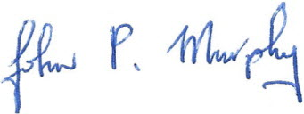
Principal

Signed: 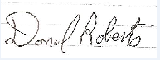
Chairman of BoM

