SAFETY AND HEALTH POLICY

DE LA SALLE COLLEGE MACROOM

In accordance with the Safety, Health and Welfare at Work Act 2005, it is the policy of the Board of Management to ensure, so far as is reasonably practicable, the safety, health and welfare at work of all staff and to protect pupils, visitors, contractors and other persons at the school from injury and ill health arising from any work activity. The successful implementation of this policy requires the full support and active co-operation of all staff, contractors and pupils of the school.

It is recognised that hazard identification, risk assessment and control measures are legislative requirements which must be carried out by the employer to ensure the safety, health and welfare of all staff.

This policy is rooted in the school’s fundamental aim to assist students to develop their full potential in an atmosphere of co-operation and mutual respect.

The Board of Management, as employer, undertakes in so far as is reasonably practicable to:

- Promote standards of safety, health and welfare that comply with the provisions and requirements of the Safety, Health and Welfare at Work Act and other relevant legislation, standards and codes of practice
- Provide information, training, instruction and supervision where necessary, to enable staff to perform their work safely and effectively
- Maintain a constant and continuing interest in safety and health matters pertinent to the activities of the school
- Continually improve the system in place for the management of occupational safety and health and review it periodically to ensure it remains relevant, appropriate and effective
- Consult with staff on matters relating to safety, health and welfare at work
- Provide the necessary resources to ensure the safety, health and welfare of all those to whom it owes a duty of care, including staff, pupils, contractors and visitors
- Ensure that all requirements in relation to emergency measures as may be defined from time-to-time by the Department of Education and Skills and/or the HSE, shall be implemented as per the advice of those and any other relevant Government agencies.

The Board of Management is committed to playing an active role in the implementation of this occupational safety and health policy and undertakes to review and revise it in light of changes in legislation experience and other relevant developments.

Signed:
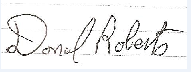

Chairperson, Board of Management De la Salle College, Macroom, Co. Cork

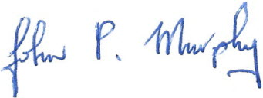
Principal

DATE : ________25/01/24_________________________________

