Agreed Report BoM DLS 30/09/21
1. Matters Arising:
- The school has received 10 CO2 monitors and these along with the 3 we already had are proving very helpful in the implementation of our Covid protocols.
2. Correspondence:
- The teacher allocation for 2021/2022 has come in .
- There are 390 students registered for 2021/2022.
- The Covid Capitation grant has arrived.
3. School Building Updates:
- Our new temporary accommodation is due to be completed by Jan 2022.
- The remaining money from Covid minor works provision will be spent on new windows for the school.
4. Appointment of committee for Post of Responsibilities Interviews:
- A panel was agreed to undertake these upcoming interviews.
5. Principals Report:
Mr Murphy highlighted the following:
Staff:
- Congratulations were passed onto teachers for all their hard work in relation to the recent excellent Leaving Cert results which were achieved by our students.
- Congratulations were passed onto staff members who recently welcomed new babies into their families.
Students:
- 80 new students started in first year this year and 6 new students have attended our ASD units.
- Parent/Teacher reports will again this year take the place of Parent/Teacher meetings due to Covid restrictions.
- Lockers are being reintroduced for most year groups on a phased basis to allow us to comply with Covid restrictions.
- Certain year groups will go to Ballyhass Water Park this year as a bonding exercise.
- Transition year activities have commenced on Friday afternoons and work experience is expected to go ahead later in the school year.
- All GAA activities have recommenced and matches will follow on at a later stage.
Parents:
- Parents are to be surveyed at a later date to gauge their opinion regarding the introduction of a school jacket.
- The Parents Association AGM will take place on 04/11/21.
- Due to covid restrictions our Open Night has been replaced with a virtual tour and Q&A session with the national School 6th class pupils.
- 90 places will be made available for incoming first years in 2022/2023.
8. Mandatory Report:
- 13 different teachers have been paid money from the OLCS since our last board meeting.

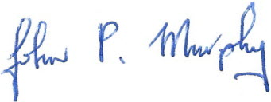
Secretary of the Board of Management

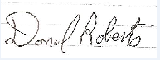
Chairman of the Board of management

