Agreed Report – 25-01/24
- Matters Arising:
- First Year student enrolment applications 2024-2025.
- Dept funding for cost of living grant.
- Correspondence:
- AMCSS updates:
- Leaving Cert Curriculum changes 2025
- Free Book Scheme
- SEC-LC grade adjustments to continue
- Sandy Hill site access query
3.School Building Updates:
- Design Team stage 1 presentation to DES on 19/12/2023
- School property in the town park has been outlined and staked.
- School roof repairs undertaken in Jan.
4.Financial Report:
- Bob Hennessy (FDC) provided a comprehensive overview of the annual financial accounts for 2022-2023.
5. Policies:
- The following policies were ratified:
- Assessment
- H&S Statement
- H&S policy
- Substance Use/Misuse Policy
- Code of Behaviour
6.Principals Report:
- Staff:
- Two teacher availed of parental leave since 6/11/23
- Two teachers had career break extensions granted
- Additional Needs support has expanded from Jan to June 2024.

- Students:
- U14 Footballers have qualifies from the group stages of the U14 county championship undefeated.
- TY Students undertook work experience in Dec 2023
- Conor Creedon (TY) was selected to exhibit his project in the finals of the young scientist competition.
- Macroom charities appeal collection took place from 12-14 Dec.
Parents:
- Parents Association Table Quiz will be on 23/02/24

- Mandatory Report:
- 13 different teachers were paid under the OLCS since the last meeting.
- All Child Protection, Bullying and Suspensions since our last meeting were reviewed and discussed.
- AOB
- Nil.

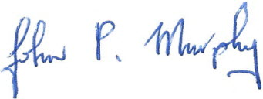
Secretary of the Board of Management

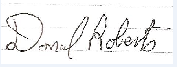
Chairman of the Board of management

